**DAILY ONLINE ACTIVITIES SUMMARY**

|  |  |  |  |  |  |  |  |  |
| --- | --- | --- | --- | --- | --- | --- | --- | --- |
| **Date:** | **09/07/2020** | | | | | **Name:** | **VIRESH** | |
| **Sem & Sec** | **4th SEM & ‘B’ SEC.** | | | | | **USN:** | **4AL18CS097** | |
| **Online Test Summary** | | | | | | | | |
| **Subject** | | **---** | | | | | | |
| **Max. Marks** | | **-** | | **Score** | | | **-** | |
| **Certification Course Summary** | | | | | | | | |
| **Course** | **Introduction to Cyber Security** | | | | | | | |
| **Certificate Provider** | | | **Greatlearning Academy** | | **Duration** | | | **7.0 Hrs.** |
| **Coding Challenges** | | | | | | | | |
| **Problem Statement 1:** ----------- | | | | | | | | |
| **Status: ------** | | | | | | | | |
| **Uploaded the report in Github** | | | | | **-----** | | | |
| **If yes Repository name** | | | | | **------** | | | |
| **Uploaded the report in slack** | | | | | **Yes** | | | |

**Online Test Summary:** **No internals conducted today.**

**Online Certification Course Summary: Today I have learnt about some remaining concepts of blockchain in Cybersecurity and industry landscape and finally I have finished this certification course.**

**The snapshots of today’s session is attached below.**

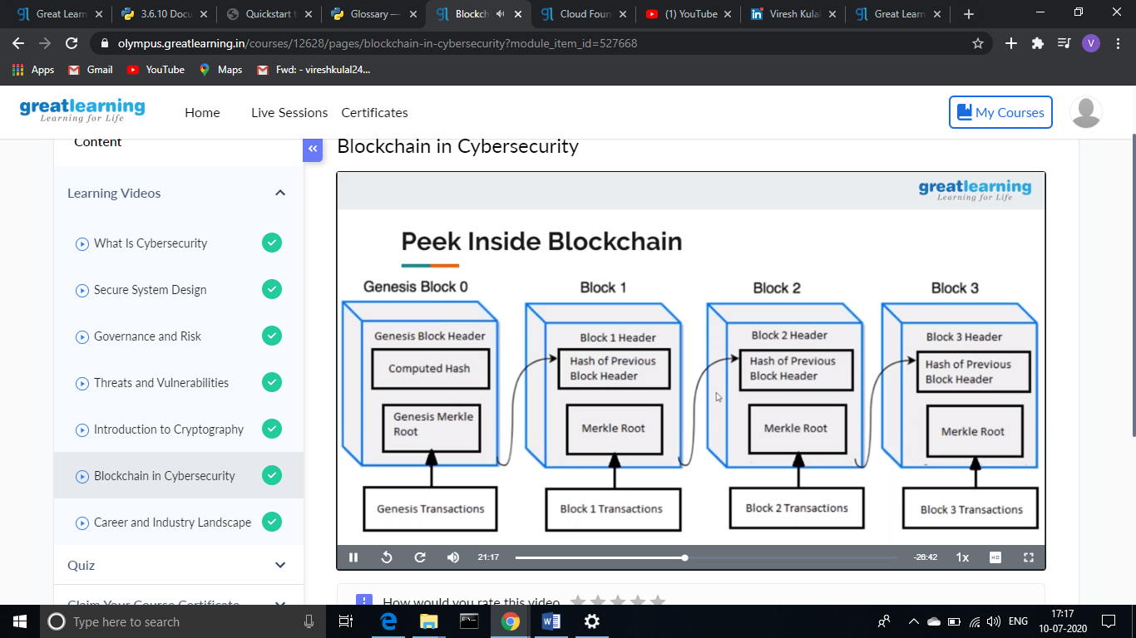 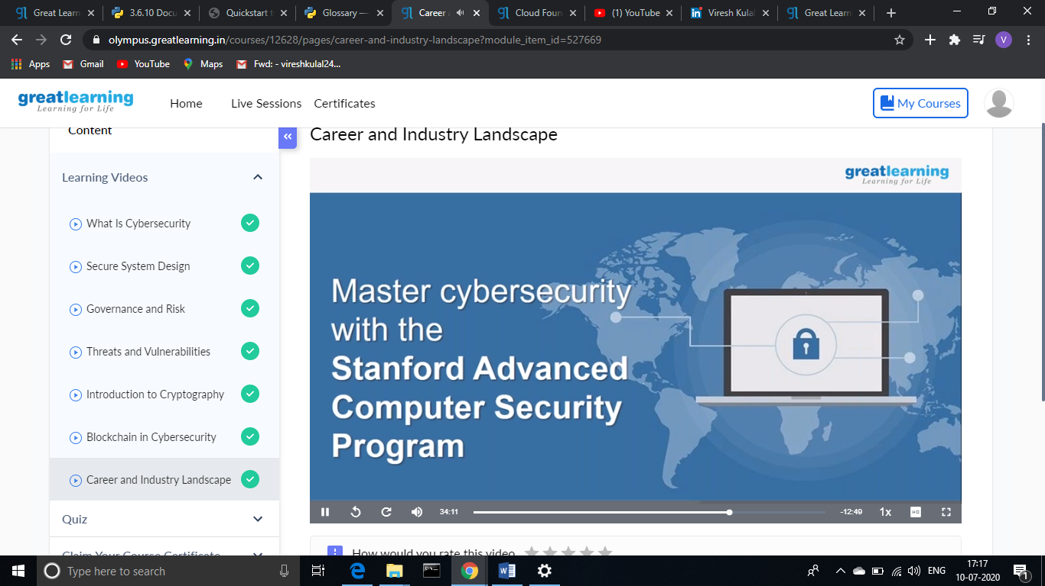

**Online Coding Summary: No problem statements are given.**

**Online Training: Today I had attended the online training organized by CSE Department AIET. The training was on C++ programming language done by Prof. Shruthi Shetty J. CSE Dept. After the session the two programs were given to write.**

**Thank You.**